**How To Set Up Apache Virtual Hosts**

-You need to do several steps in order to make this work.

1. Update hosts file

Open the system hosts file, generally found at c:\WINDOWS\system32\drivers\etc\hosts in a text editor.



And then , You will find the following line in it.

127.0.0.1       localhost

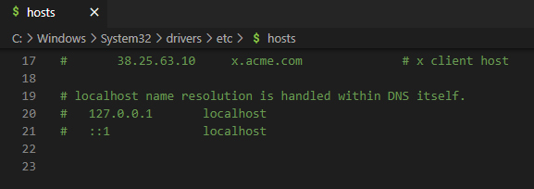

Add the following lines below it

127.0.0.1       example.test

You need to add 1 line for every domain that you want to host on your server. See the following

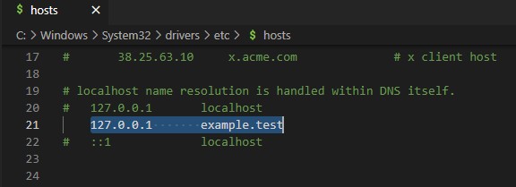

2 . Create Folders For Domains

Next, create separate folders, 1 for each domain in your Apache document root location C:/Apache24/htdocs.



If you are using XAMPP then you need to create these folders at C:/xampp/htdocs instead.

3. Update Virtual Hosts in Apache Configuration

Open virtual host configuration file located at apache\conf\extra\httpd-vhosts.conf in a text editor.

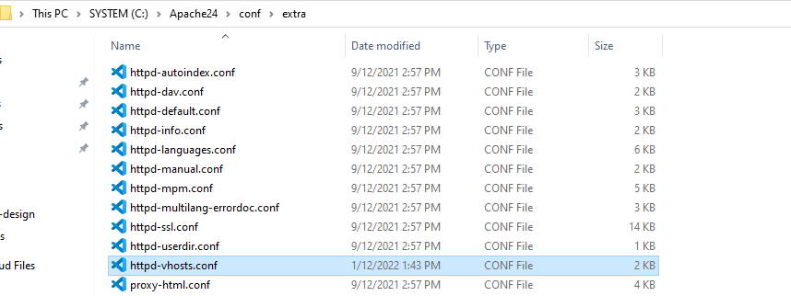

And then Add the following Virtual Host tag for domain.

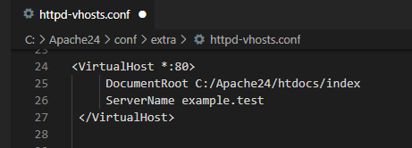

* DocumentRoot is your project folder path .

See the following Sample for Laravel project with Apache Virtual Host

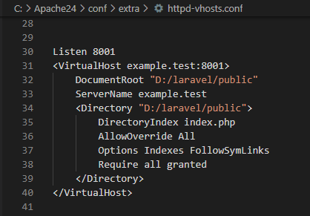

Listen is used for new port number creation . You can use default port number 80.

4. Check Configuration File

Uncomment the following line in it by removing # at its beginning.

Conf path - C:\Apache24\conf\httpd.conf

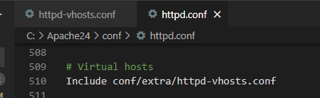

5 . Final Step

Restart the Apache in Service.

** Now you can run with virtual host with Apache.**

